

SQITK3073
Business Analytics Programming

(GROUP A)

Individual Assignment

PREPARED FOR:

Dr. Mohd Aamir Adeeb bin Abdul Rahim

PREPARED BY:

Quah Kai Sheng 299428

Question 1: Portfolio Construction and Return Analysis
Why These Stocks Were Selected
The five selected stocks (Maybank, CIMB, Public Bank, Tenaga Nasional, and Petronas Chemicals) were chosen based on their strong presence and activity in Bursa Malaysia.
- They are large-cap companies, meaning they are financially stable and widely recognized
- They belong to different sectors (banking, energy, chemicals), providing diversification
- They have high trading volume, making them more reliable for short-term analysis
- Data from these stocks is more consistent and easier to analyse, which improves accuracy
Overall, selecting these stocks is beneficial because it ensures the analysis is realistic, balanced, and representative of the Malaysian market.
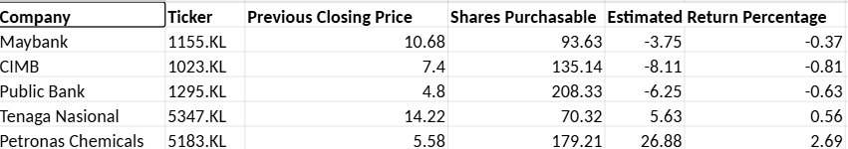
Question 2(a): Data Filtering Using Pandas Slicing
Explanation
This summary table helps investors by simplifying the data and highlighting only key performance indicators. Instead of analysing a large dataset, investors can quickly compare:
- Which stock generated the highest return
- Which stock performed poorly
- Overall performance differences between stocks
This makes decision-making faster and more efficient.
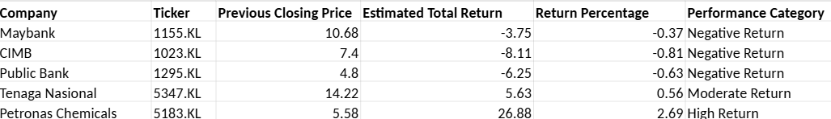

Question 2(b): GroupBy Analysis
Explanation
This classification helps investors understand overall portfolio performance by grouping similar stocks together.
- It shows whether most stocks are performing well or poorly
- It highlights which category contributes the most profit
- It simplifies analysis by focusing on group trends instead of individual stocks
Overall, this makes it easier to evaluate the portfolio at a higher level.
Performance | Category
High Return | 26.880000
Moderate Return | 5.630000
Negative Return | -6.036667
Question 3(a): Closing Price Trend Visualization
A line chart was created to show the closing price trends of all five stocks over the one-month period.
Key Insights
- Stock prices fluctuate over time due to market conditions
- Tenaga Nasional shows a stable and strong trend, maintaining the highest price level
- CIMB shows a downward trend, indicating weaker performance
- Petronas Chemicals fluctuates more, suggesting higher volatility
This chart helps investors identify which stocks are stable and which are more risky.

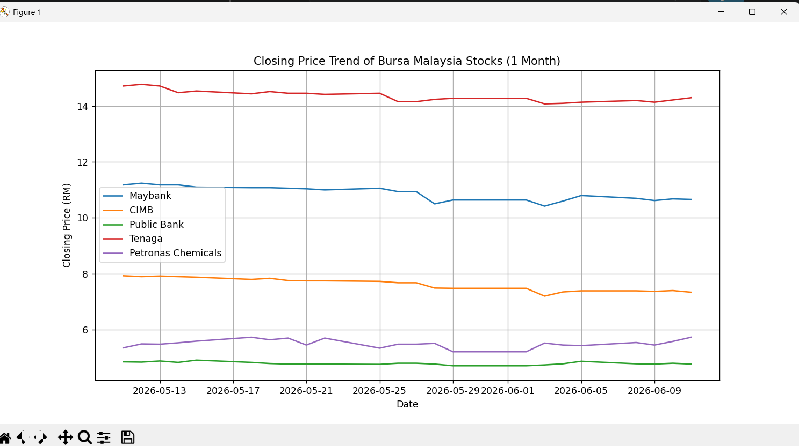
Question 3(b): Portfolio Performance Comparison
A bar chart was created to compare the return percentages of all five stocks.
Key Insights
- The chart clearly shows the best-performing stock (highest return)
- It also highlights underperforming or negative-return stocks
- Investors can easily compare profitability across all stocks
This visual representation makes it easier to understand performance differences at a glance.
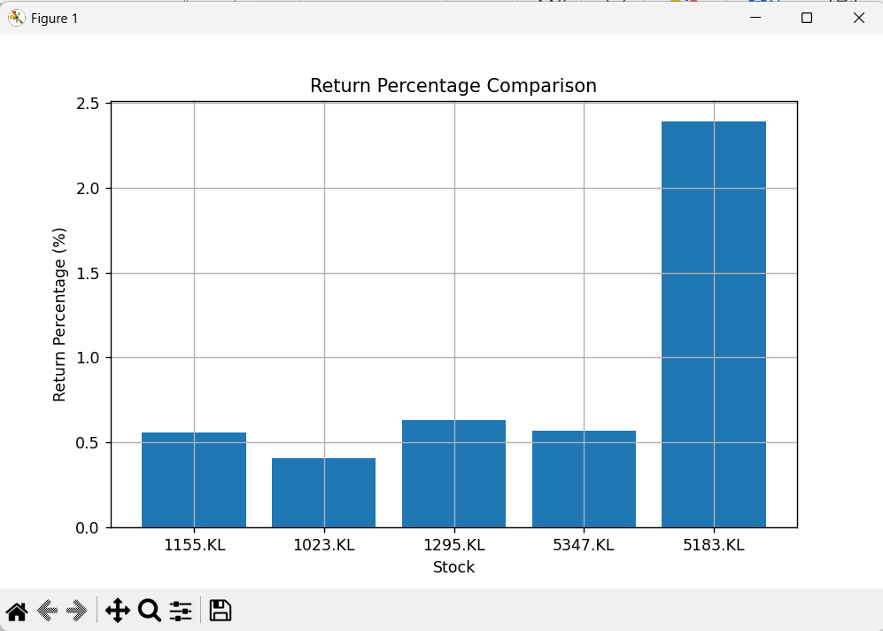

Question 4: Discussion
1. Stock with the Strongest Price Performance
Based on the analysis, Tenaga Nasional shows the strongest price performance over the one-month period.
Its closing price remains consistently high (around RM14+) and relatively stable compared to the other stocks. This indicates lower volatility and strong investor confidence. While other stocks such as CIMB show a declining trend and Petronas Chemicals fluctuates more, Tenaga Nasional maintains a steady position, making it the strongest performer in this analysis.

2. Limitations of the Analysis
There are several limitations to this analysis:
- The study only covers one month, which may not represent long-term trends
- Only price data is considered, without financial performance indicators
- Trading volume is not included, limiting insights into market activity
- External factors such as economic conditions and news events are ignored
- Only five stocks are analysed, which may not reflect the entire market

3. Other Factors Investors Should Consider
Before making investment decisions, investors should consider additional factors beyond short-term price movement:
- Fundamental analysis (profit, revenue, financial health)
- Economic conditions (interest rates, inflation, policies)
- Industry trends and competition
- Risk and volatility levels
- Company news and developments
- Long-term growth potential
Reference

Yahoo Finance. (2026). Stock market data and financial information. Retrieved from https://finance.yahoo.com
Ran Aroussi. (2026). yfinance: Yahoo Finance market data downloader. Retrieved from https://pypi.org/project/yfinance/
Pandas Development Team. (2026). pandas documentation. Retrieved from https://pandas.pydata.org/docs/
Matplotlib Development Team. (2026). matplotlib documentation. Retrieved from https://matplotlib.org/stable/index.html
Bursa Malaysia. (2026). Market information and listed companies. Retrieved from https://www.bursamalaysia.com

APPENDIX
GitHub Repository Link
https://github.com/quahbig78-art/Quah/tree/main/python%20assignment%202.0

LLM Usage Statement
I used ChatGPT (OpenAI) for guidance on:
• yfinance library usage
• pandas DataFrame structuring
• Debugging code
• Slicing and groupby concepts
• Plotting charts with matplotlib All stock choices, analysis, and conclusions are my own.
All stock selection, data interpretation, and final conclusions are my own work.

List of Files Submitted
QuestionV1.py
QuestionV2a.py
QuestionV2b.py
QuestionV3a.py
QuestionV3b.py

